2021 Viking Football
Shoot – Out Shirts
100 Shirts With Your
1 Color Business Logo

Shirts Will Be Shot Into The Crowd Before Each Home Game.

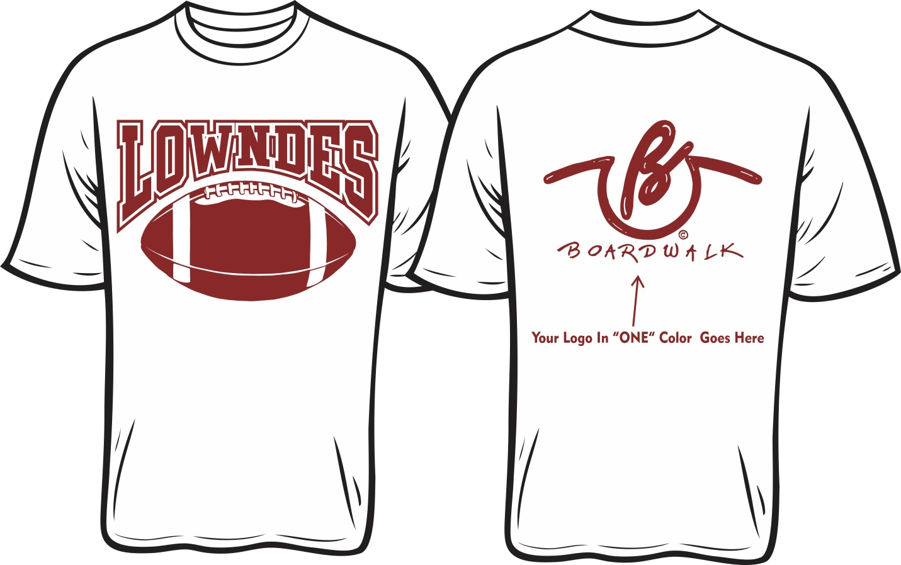
10 to 18 Of Your Shirts Will Be Shot Each Week

$800 – Checks Payable To Viking Touchdown Club
(Call Darrell Presley @ 229-740-2564 for additional information)
_________________________________________Business Name Attach Business Logo Contact Name

